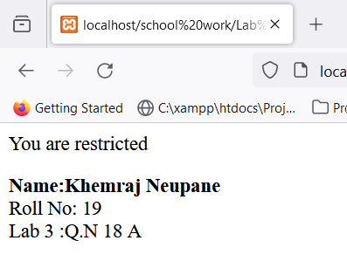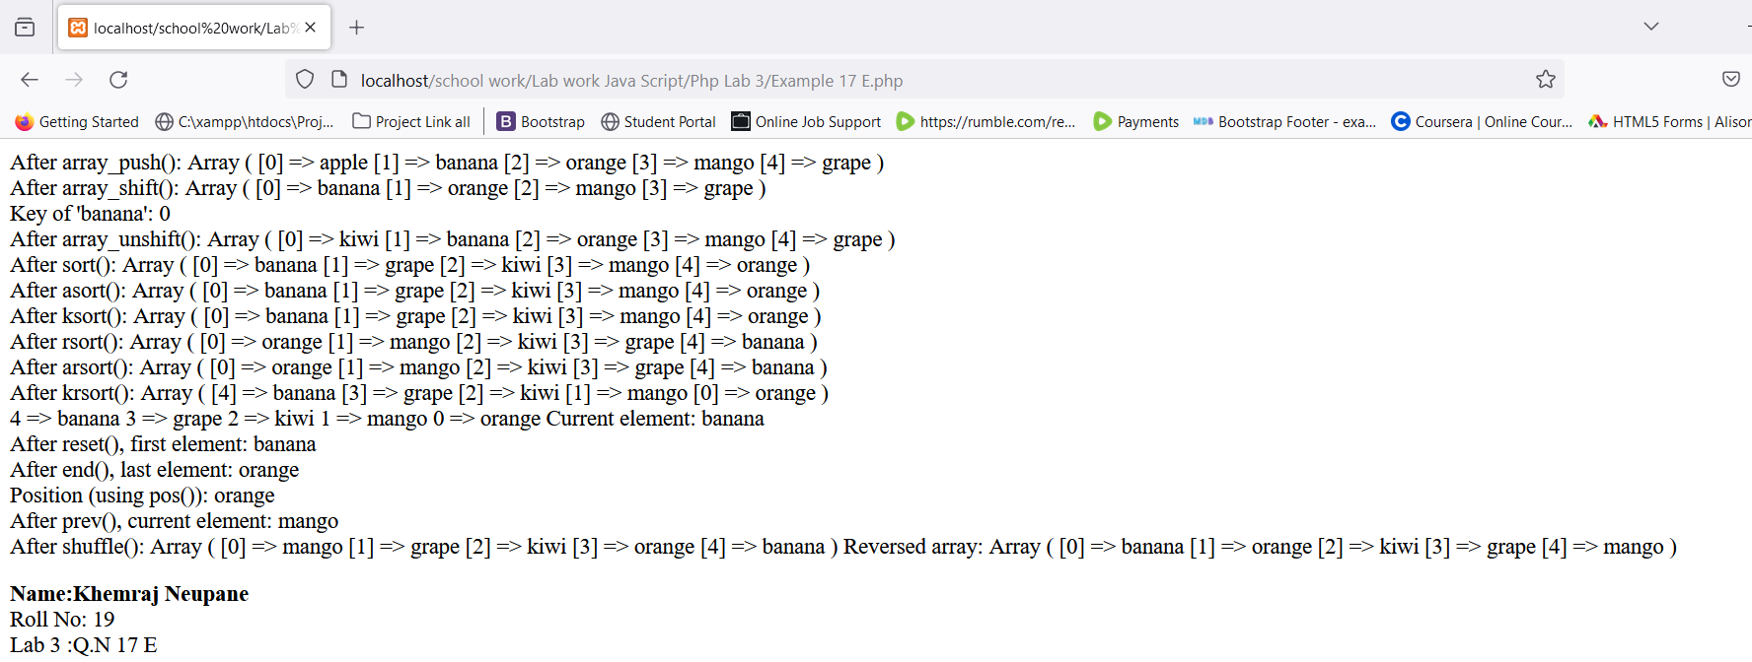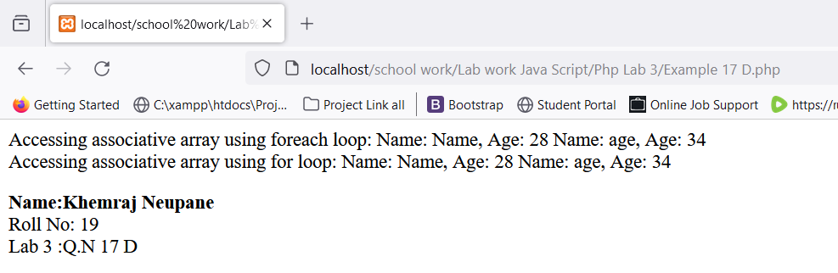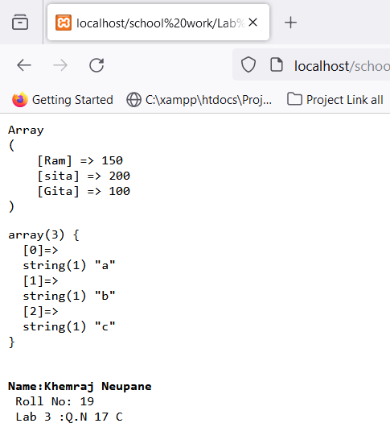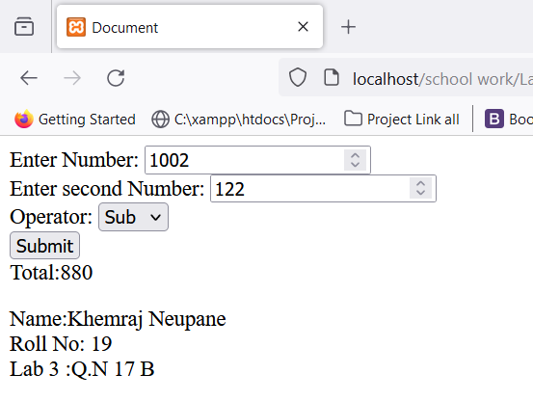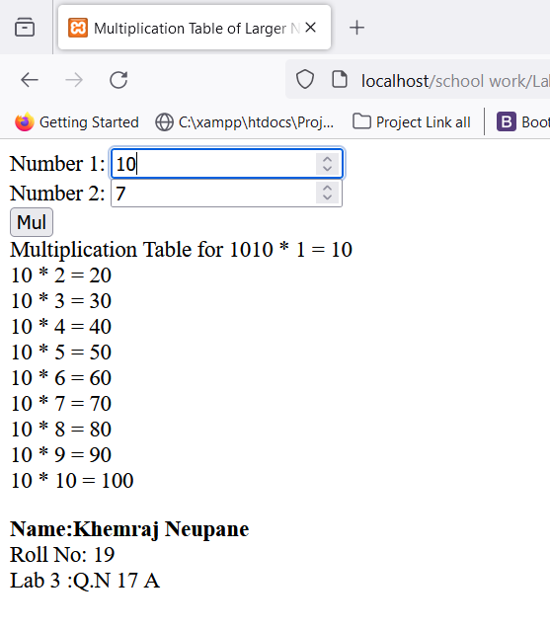

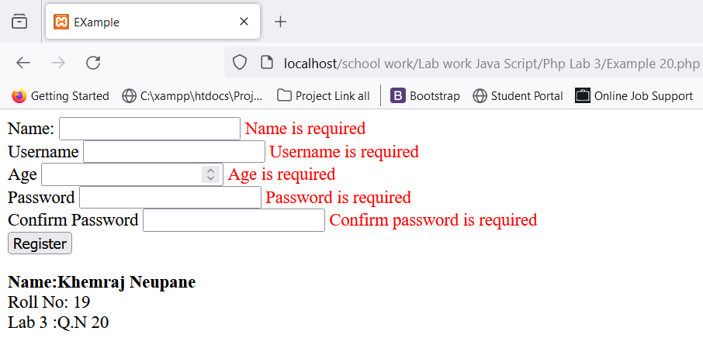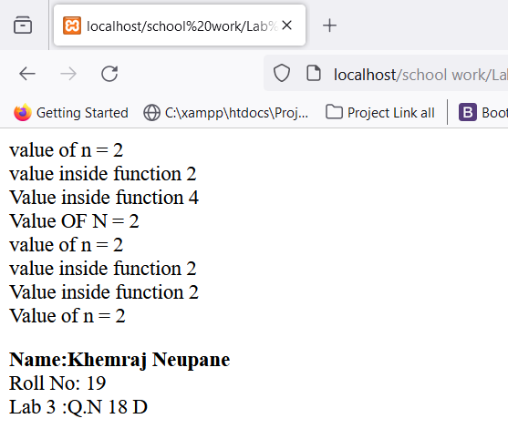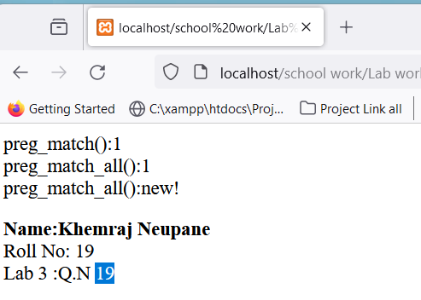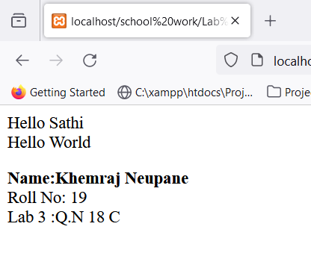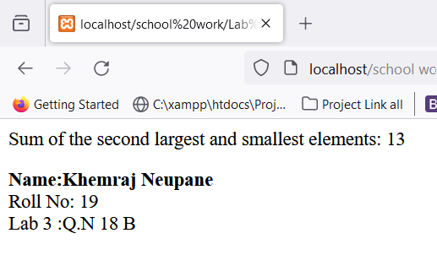

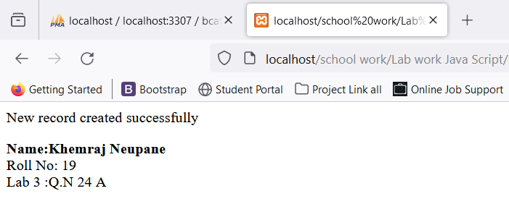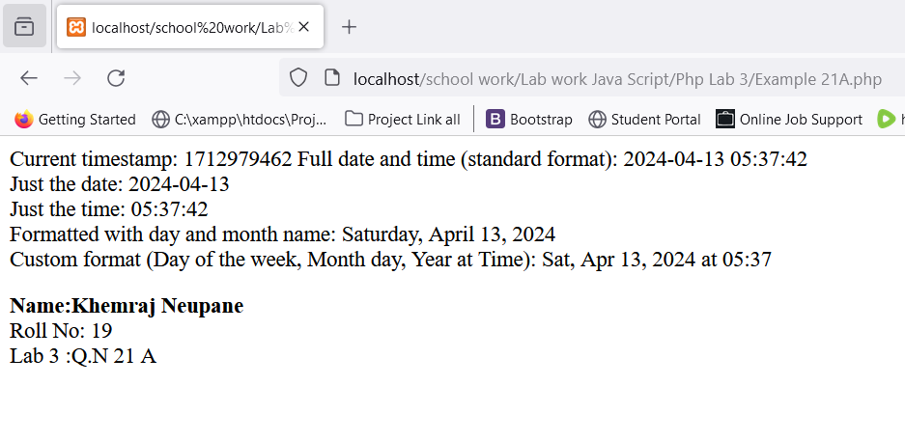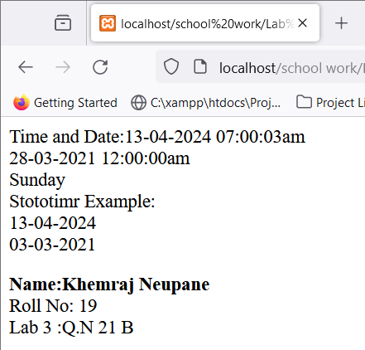

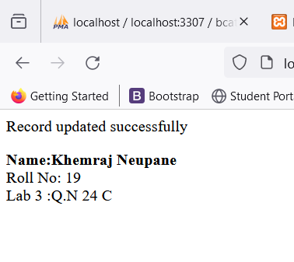

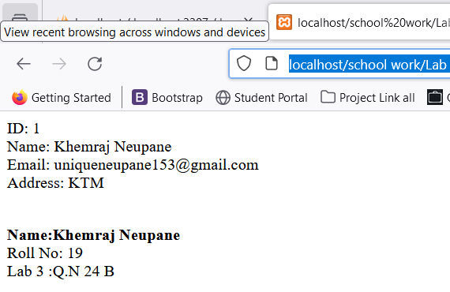

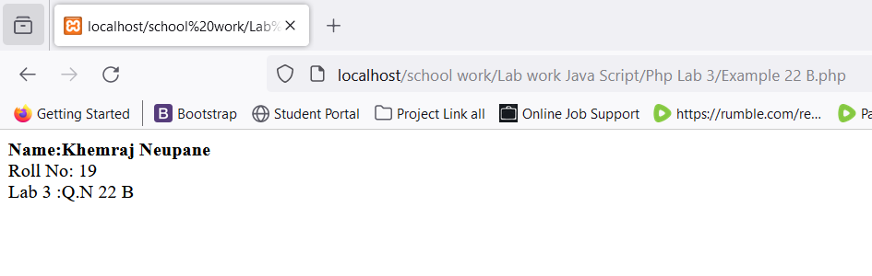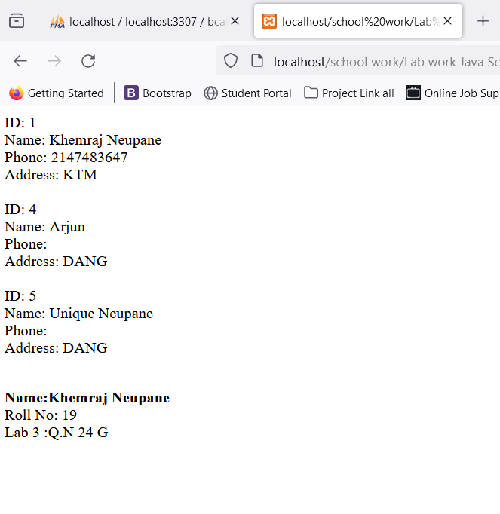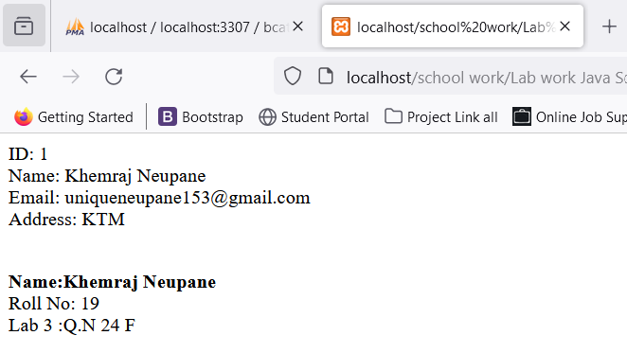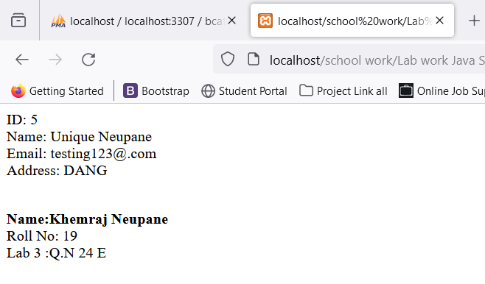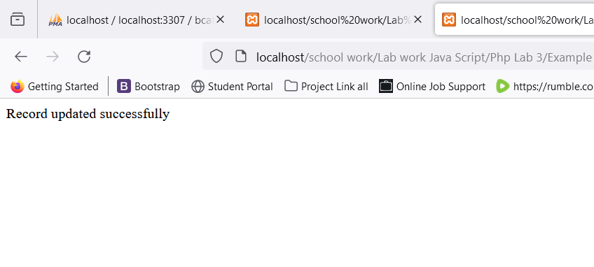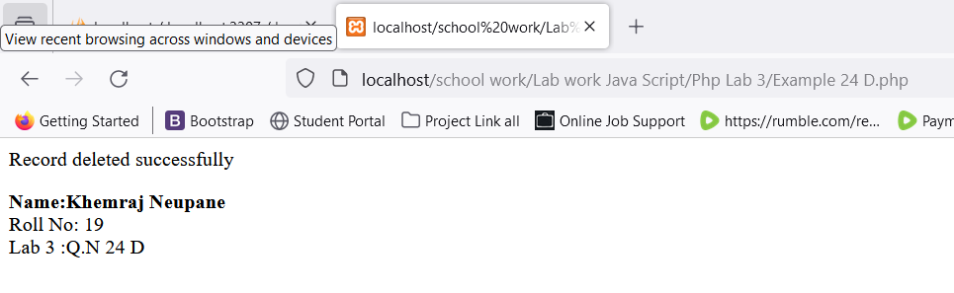

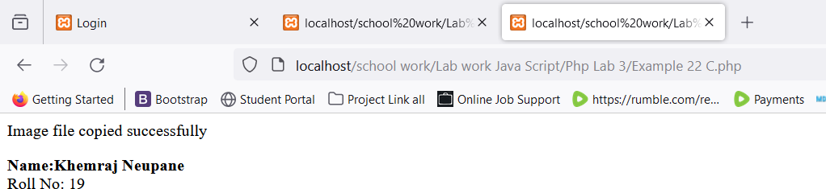

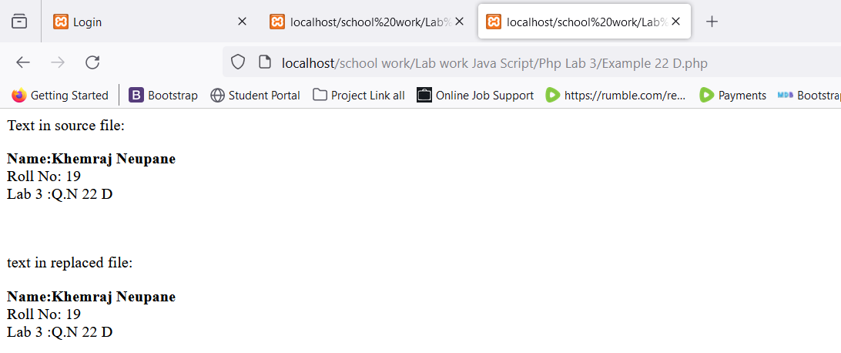

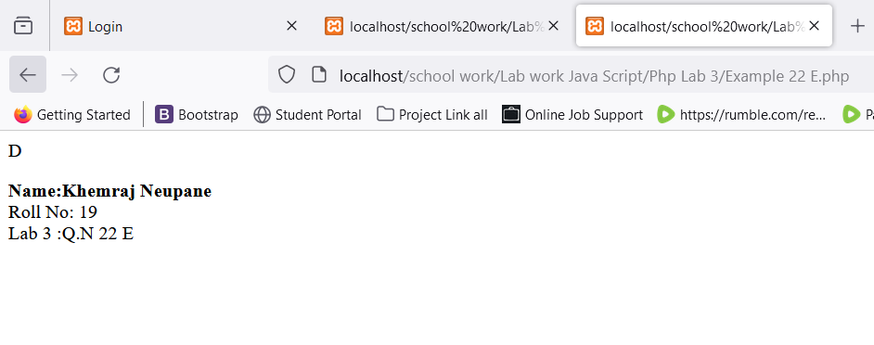

# Q.N 25

DATABASE FILE:

<?php

$servername = "localhost:3307";

$username = "root";

$password = "";

$dbname = "news_website";

$conn = mysqli_connect($servername,$username,$password,$dbname);

if(!$conn){

die("Could not connect: " . mysqli_connect_error());

}

?>

ADD POST

<?php

include "header.php";

include ("../database/database.php");

?>

<!-- Start Html Code Here -->

<div class="add_container">

<h1 class="head">Add Post</h1>

<!-- Start Form code -->

<form action="Post Save.php" method="POST" enctype="multipart/form-data" id="form" name="post" onsubmit="return validationPost()">

<!--Title filed -->

<div class="input-box">

<label>Title <span style="color:red;">*</span></label>

<input type="text" name="title" id="title">

<small>Error Message</small>

</div>

<!-- Description filed -->

<div class="input-box">

<label>Description <span style="color:red;">*</span></label>

<textarea name="description" id="description" cols="20" rows="10"></textarea>

<small>Error Message</small>

</div>

<!-- Category filed -->

<div class="input-box">

<label>Category <span style="color:red;">*</span></label>

<select name="category" id="category">

<option disabled selected>Select</option>

<?php

$sql = "SELECT * FROM post_category WHERE status < 1";

$result = mysqli_query($conn, $sql) or die("query failed");

if (mysqli_num_rows($result) > 0) {

while ($row = mysqli_fetch_array($result)) {

echo "<option value='{$row['category_id']}'>{$row['category_name']}</option>";

}

}

?>

</select>

<small>Error Message</small>

</div>

<!-- Image filed -->

<div class="input-box">

<label>Image <span style="color:red;">*</span></label>

<input type="file" name="UploadImg" id="image">

<small>Error Message</small>

</div>

<input type="submit" name="POST" value="Post" class="btn">

</form>

</div>

<!--End Html Code Here-->

POST SVAE FILE

<?php

include ("../database/database.php");

// upload file

if(isset($_FILES['UploadImg']['name'])){

$errors= array();

$file_name = $_FILES['UploadImg']['name'];

$file_size = $_FILES['UploadImg']['size'];

$file_tmp = $_FILES['UploadImg']['tmp_name'];

$file_type = $_FILES['UploadImg']['type'];

$file_ext = end(explode(".",$file_name));

$extensions = array("jpeg","jpg","png");

// check if size

if(in_array($file_ext, $extensions) === false){

$errors[] = "plseae choose file a jpg or png or jpeg file ";

}

if($file_size > 5242880 ){//check file mb (1024*1024=1mb)

$errors[] = "file size must be 5mb or lower.";

}

$new_name = time(). "--".basename($file_name);

$target = "Post UploadImg/".$new_name;

if(empty($errors) == true){

move_uploaded_file($file_tmp,$target);

}

else{

print_r($errors);

die();

}

}

session_start();

$title = mysqli_real_escape_string($conn, $_POST['title']);

$description = mysqli_real_escape_string($conn, $_POST['description']);

$category = mysqli_real_escape_string($conn, $_POST['category']);

$author = $_SESSION['user_id'];

$date = date("Y-D-M");

$sql ="INSERT INTO news_post (post_title, post_description, category, author, date, post_Uploadimg) VALUES ('{$title}', '{$description}', '{$category}', {$author}, '{$date}', '{$new_name}');";

$sql .="UPDATE post_category SET category_post = category_post + 1 WHERE category_id = {$category}";

if(mysqli_multi_query($conn, $sql)){

header("location: Post.php");

}

else{

echo "<div class= 'alert alert-danger'>Failed..</div>";

}

?>

POST UPDATE FILE

<?php

include "header.php";

include ("../database/database.php");

if ($_SESSION['user_role'] == 0) {

$post_id = $_GET['id'];

$sql2 = "SELECT author FROM news_post WHERE post_id = {$post_id}";

$result2 = mysqli_query($conn, $sql2) or die("Query Failed");

$row2 = mysqli_fetch_assoc($result2);

if ($row2['author'] != $_SESSION['user_id']) {

header("location:Post.php");

}

}

?>

<?php

$post_id = $_GET['id'];

$sql = "SELECT news_post.post_id, news_post.post_title, news_post.post_description,news_post.category, news_post.post_Uploadimg,post_category.category_name, news_post.category FROM news_post

LEFT JOIN post_category ON news_post.category =post_category.category_id

LEFT JOIN add_user on news_post.author = add_user.user_id

WHERE news_post.post_id = {$post_id}";

$result = mysqli_query($conn, $sql) or die("Query Failed");

if (mysqli_num_rows($result) > 0) {

while ($row = mysqli_fetch_assoc($result)) {

?>

<!-- Update Html Code Start.. -->

<div class="add_container">

<h1 class="head">Update Post</h1>

<!-- Start Form code -->

<form action="post_save_postupdate.php" method="POST" enctype="multipart/form-data" name="post" id="form" onsubmit="return validationPost()">

<div class="input-box">

<input type="hidden" name='post_id' value="<?php echo $row['post_id']; ?>">

</div>

<!--Title filed -->

<div class="input-box">

<label>Title <span style="color:red;">*</span></label>

<input type="text" name="title"id="title" value="<?php echo $row["post_title"]; ?>">

<small>Error Message</small>

</div>

<!-- Description filed -->

<div class="input-box">

<label>Description <span style="color:red;">*</span></label>

<textarea name="description" id="description" cols="20" rows="10"><?php echo $row["post_description"]; ?></textarea>

<small>Error Message</small>

</div>

<!-- Category filed -->

<div class="input-box">

<label>Category <span style="color:red;">*</span></label>

<select name="category" id="category">

<option disabled selected> Select </option>

<?php

$sql1 = "SELECT * FROM post_category WHERE status < 1";

$result1 = mysqli_query($conn, $sql1) or die("query failed");

if (mysqli_num_rows($result1) > 0) {

while ($row1 = mysqli_fetch_assoc($result1)) {

if ($row['category'] == $row1['category_id']) {

$selected = "selected";

} else {

$selected = "";

}

echo "<option value='{$row1['category_id']}'$selected>{$row1['category_name']}</option>";

}

}

?>

</select>

<input type="hidden" name="old_category" value="<?php echo $row['category']; ?>">

<small>Error Message</small>

</div>

<!-- Image filed -->

<div class="input-box">

<label>Image <span style="color:red;">*</span></label>

<input type="file" name="new-image">

<img src="Post UploadImg/<?php echo $row['post_Uploadimg']; ?>" width="200px" height="200px">

<input type="hidden" name="old_image" value="<?php echo $row['post_Uploadimg']; ?>" id="image"> <!-- Old image Upload file -->

<small>Error Message</small>

</div>

<input type="submit" name="Post" value="Update" class="btn">

</form>

<?php }

} else {

echo "Not Found";

}?>

</div>

POST_SAVE_UPDATE_POST

<?php

include ("../database/database.php");

if(empty($_FILES['new-image']['name'])){

$new_name = $_POST['old_image'];

}else{

// upload file

$errors= array();

$file_name = $_FILES['new-image']['name'];

$file_size = $_FILES['new-image']['size'];

$file_temp = $_FILES['new-image']['tmp_name'];

$file_type = $_FILES['new-image']['type'];

$tmp = explode('.',$file_name);

$file_extension = end($tmp);

$extensions = array("jpeg","jpg","png");

if(in_array( $file_extension, $extensions) === false){

$errors[] = "plseae choose file a jpg or png or jpeg file ";

}

// check if size

if($file_size > 5242880 ){//check file mb (1024*1024=1mb)

$errors[] = "file size must be 5mb or lower.";

}

$new_name = time(). "--".basename($file_name);

$target = "Post UploadImg/".$new_name;

$image_name = $new_name;

if(empty($errors) == true){

move_uploaded_file($file_temp,$target);

}

else{

print_r($errors);

die();

}

}

$title = mysqli_real_escape_string($conn, $_POST["title"]);

$description = mysqli_real_escape_string($conn, $_POST["description"]);

$category = mysqli_real_escape_string($conn, $_POST["category"]);

$post_id = mysqli_real_escape_string($conn, $_POST["post_id"]);

$old_category = mysqli_real_escape_string($conn, $_POST["old_category"]);

$query = "UPDATE news_post SET `post_title`='{$title}', `post_description`='{$description}', `category`={$category}, `post_Uploadimg`='{$new_name}' WHERE post_id ={$post_id};";

if($old_category != $category){

$query .= "UPDATE post_category SET category_post = category_post -1 WHERE category_id={$old_category};";

$query .= "UPDATE post_category SET category_post = category_post +1 WHERE category_id={$category}";

}

$result =mysqli_multi_query($conn, $query);

if($result){

header("location:Post.php");

}

else{

echo "Query Failed";

}

?>

DELETE POST

<?php

include ("../database/database.php");

$post_id = $_GET['id'];

$category_id = $_GET['category_id'];

// Delete Image Folder code

$sql1 = "SELECT * FROM news_post WHERE post_id = {$post_id};";

$result = mysqli_query($conn, $sql1) or die("Query Failed :SELECt");

$row = mysqli_fetch_assoc($result);

unlink("Post UploadImg/".$row['post_Uploadimg']);

// Delete end code

$sql = "DELETE FROM news_post WHERE post_id = {$post_id};";

$sql .= "UPDATE post_category SET category_post = category_post -1 WHERE category_id={$category_id}";

if(mysqli_multi_query($conn, $sql)){

header("location:Post.php");

}

else{

echo "Failed";

}

?>

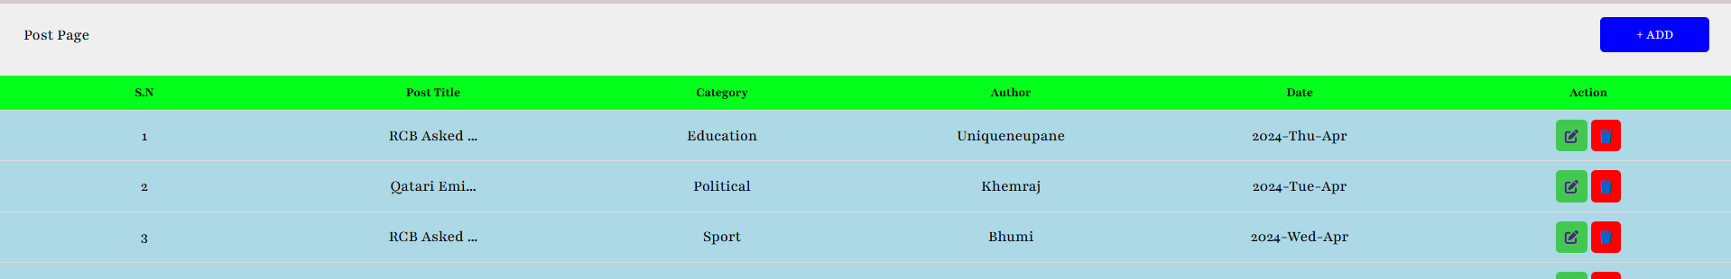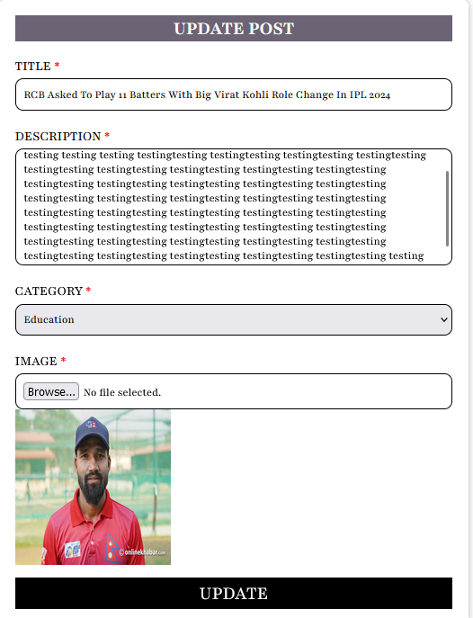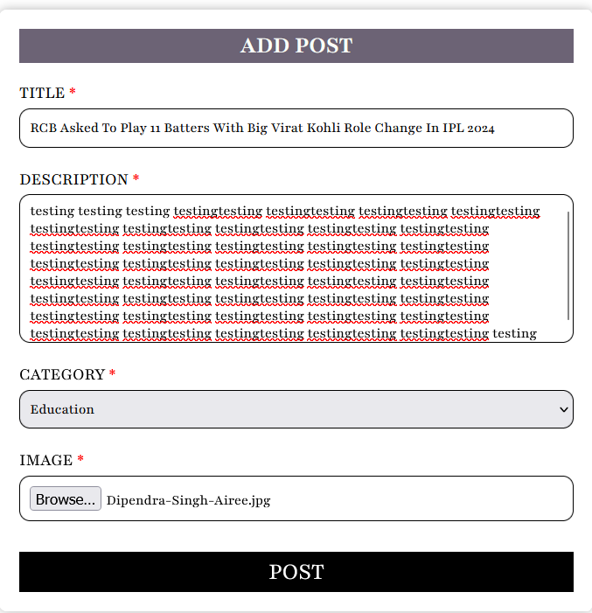OUTPUT